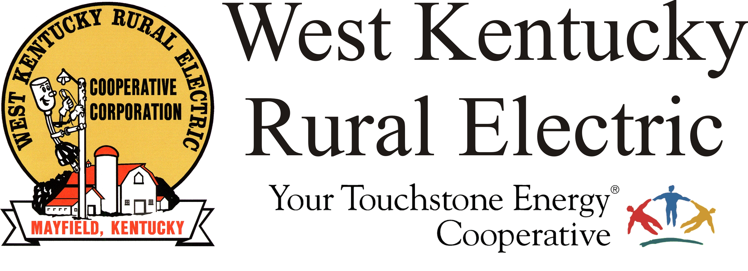

West Kentucky RECC Saturday Afternoon
Storm Damage Update

(Mayfield, Ky.) Dec. 11, 2021 (1:30 p.m.) – West Kentucky Rural Electric Cooperative currently has 11 crews in the field making repairs to equipment damaged in last night storms. Outage numbers have remained essentially the same, since most are part of a larger transmission outage. By making repairs to obviously damaged equipment, we expect to have more members back online when power is restored to the substations.

About three-quarters of WKRECC’s 38,000 meters remain without power.

TVA has said they are dealing with a total of 60 damaged transmission structures in our region.

We expect to nearly double our workforce tomorrow with the addition of visiting crews from other electric cooperatives. We are grateful to these crews and to their companies for making them available to help us rebuild.

There is presently no communication capability at our headquarters office here in Mayfield. We will make you aware of any changes. Our website and outage map are both inaccessible at this time.

Please stay away from downed power lines and stay off the roads. Line crews and first responders are having trouble reaching their destinations due to heavy traffic.

We continue to expect many members will be without power for several days. Anyone with electricity-dependent medical devices or other health concerns should arrange to relocate or secure a generator. for an alternate power source. Please take steps to make sure your family is safe.

We will continue to post updates approximately every four hours.

Georgann Lookofsky
270-804-1701
glookofsky@wkrecc.com

